MythSim Microcode Language Quick Reference
Register Set
a_sel=n |  | Place the value in register n (0-7) on the a_bus.
b_sel=n |  | Place the value in register n (0-7) on the b_bus.
ri_sel |  | Store result in the register defined in ir_ri.
rj_sel |  | Place the value in the register defined by ir_rj on the a_bus.
rk_sel |  | Place the value in the register defined by ir_rk on the b_bus.
rn_write |  | Store the result_bus value into register n (0-7).
Arithmetic Logic Unit
alu_sel= | NOT | NOT(a_bus) => alu_bus
 | OR | OR(a_bus, b_bus) => alu_bus
 | AND | AND(a_bus, b_bus) => alu_bus
 | XOR | XOR(a_bus, b_bus) => alu_bus
 | ADD | a_bus + b_bus + c_in => alu_bus
 | SUB | a_bus + NOT(b_bus) + c_in => alu_bus
 | ADDA | a_bus + c_in => alu_bus
 | SUBA | a_bus -1 + c_in => alu_bus
c_in |  | Set the c_in to 1 for use by ALU operations (4-7).
Memory Interface
result_sel= | ALU | Place the alu_bus value on the result_bus.
 | MDR | Place the mdr value on the result_bus.
 | IR_CONST4 | Place ir_const4 on the result_bus. (ir_const4 = last 4 bits of ir0)
 | IR_CONST8 | Place ir_const8 on the result_bus. (ir_const8 = all 8 bits of ir0)
ir0_sel= | LOAD | Load the value on the memory_bus into ir0 (Instruction Register 0).
ir1_sel= | LOAD | Load the value on the memory_bus into ir1 (Instruction Register 1).
mar_sel= | LOAD | Load the value on the alu_bus into the mar (Memory Address Register).
mdr_sel= | LOAD_ALU | Load the value on the alu_bus into the mdr (Memory Address Register).
mdr_sel= | LOAD_MEM | Load the value on the memory_bus into the mdr (Memory Data Register).
read |  | Place the value at the main memory address mar on the memory_bus.
write |  | Write the value of mdr to the main memory location mar.
Control Structures
goto label |  | Jump to the given label.
if status_line then  goto label_1  (else goto label_2)  endif |  | If the value of status_line=1 then goto label_1 else goto label_2.
 |  | status_line | Description
 |  | m7 | most significant bit from alu_bus
 |  | c_out | carry bit from the alu_bus
 |  | v | overflow bit from the ALU
 |  | wait | wait signal from Main Memory

Control Unit Diagram
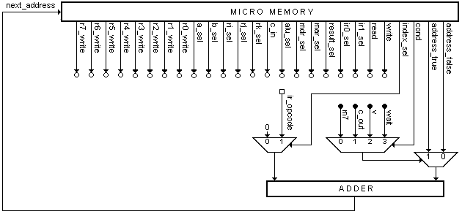
Datapath Diagram
